**Nursery Autumn Newsletter 2020**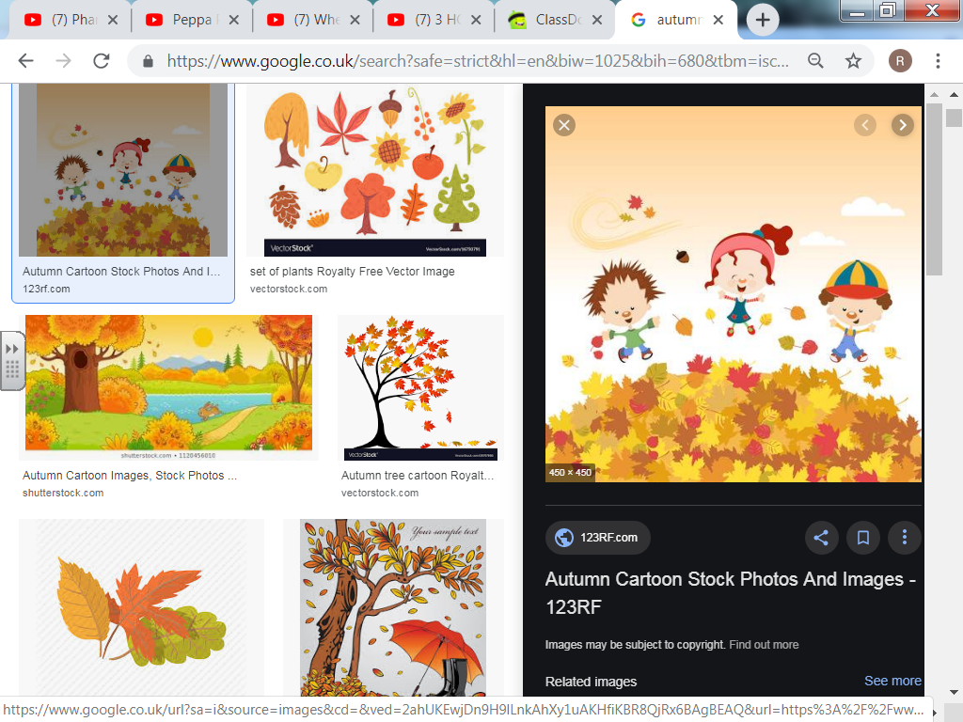

**Communication:**

Please keep up to date with what your child is doing in class by checking out our Class Blog (updated weekly).

If you need to speak to me about any questions/queries/worries etc. please feel free.

Due to the covid 19 situation any discussions are required to be done outdoors or via telephone

**Nursery Team:**

Miss R Miller

Mrs D Jones

**PE**

On a Friday we do PE, please ensure that children come into school wearing something appropriate such as joggers, trainers etc.

**Reading**

We won’t be sending any picture storybooks home with the children at the moment. Please spend time reading any picture books you have at home with your child as often as you can. We will continue to share stories together every day in class as well!

**Snack:**

**Please can children bring one piece of FRUIT in for snack each day.**

Please ensure that snack tubs/items have your child’s name clearly written on them.

If your child brings grapes for snack please ensure that they are cut appropriately.

Children will also need to bring in a bottle of **water** to drink with their snack too.

Please can all jumpers, coats snack tubs, pencil cases etc. be clearly labelled with your child’s name. This will help us to ensure that the right items go home with the right child at the end of every session.

Please can any toys be left at home rather than brought into school as there is the possibility of them getting lost in school.

**What will we be learning about this term?**

Our new theme for the Autumn term is “Africa.” We will be reading the story “We all went on Safari” which looks at a variety of African animals. 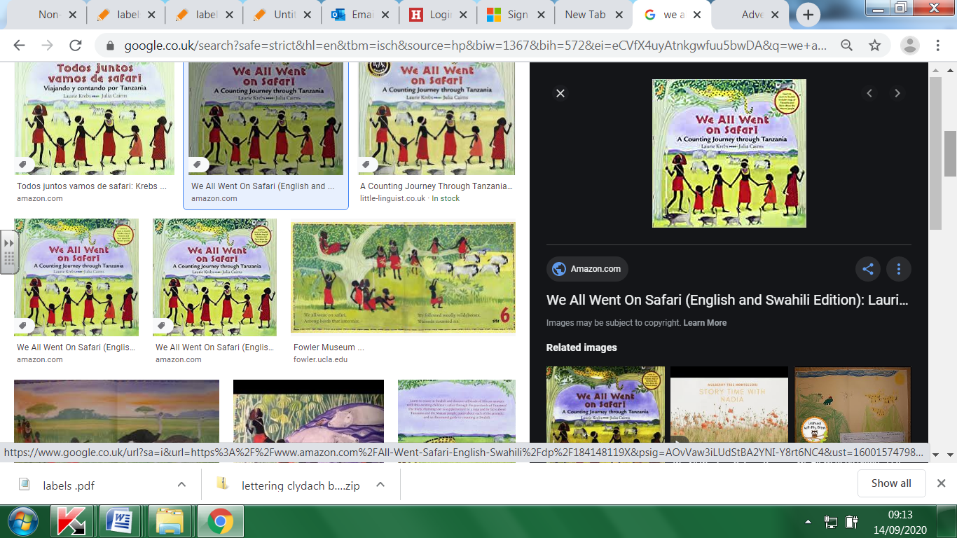

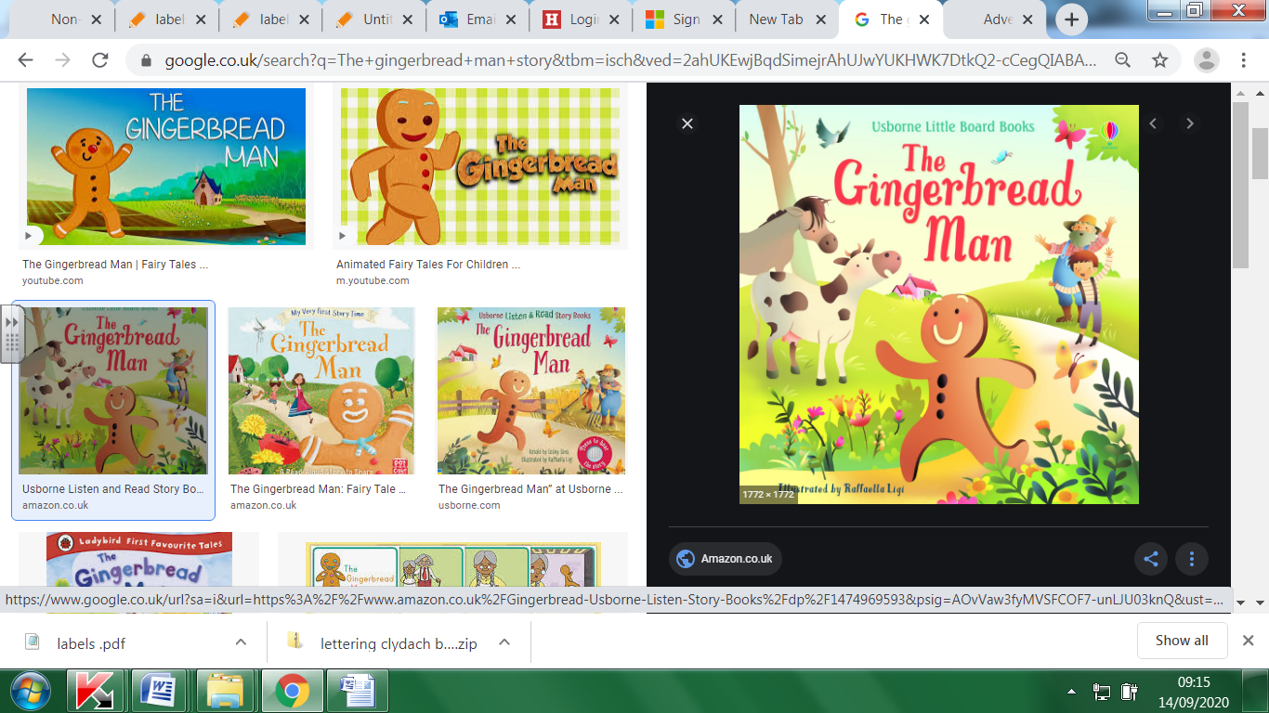We will also be looking at the story of The Gingerbread Man and learning to re-tell it.

We will be focusing on basic skills such as counting basic objects, number recognition and learning letters.