Home Learning Pack 3
The Gingerbread Man
All of the activities this fortnight are linked to The Gingerbread Man story. Please see attached documents for a copy of this story to share with your child.
Literacy Activities:
Read and share this story with your child (you can read it several times to them over the course of the fortnight so they are familiar with it).
Ask them basic recall questions about the story such as:
Who made the gingerbread man? Where did the old lady put the gingerbread man to cook? What did the fox do? etc.
Ask them to point to different things e.g. point to the old man, point to the animal behind/in front of the dog etc.
Then you could ask them deeper questions (perhaps they may struggle answering these so may need a bit of prompting) such as:
Why do you think the gingerbread man wanted to run away?
Do you think the fox was being kind when he offered to take the gingerbread man across the river?
What do you think about the fox eating the gingerbread man?
Who (if anyone) do you think should have eaten the gingerbread man?

Gingerbread Man stick puppet show:
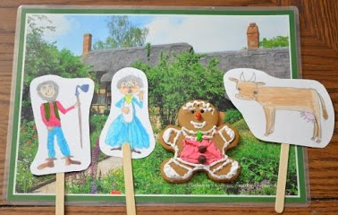
Create your own Gingerbread Man stick puppets either using templates attached or if you’re feeling creative make your own. You can use a cereal/shoe box to be the puppet theatre. Children can then act out the story using the puppets. Once they’ve acted out the story you could think of some alternative scenes yourself. For example, a conversation between all the characters as they walked back home after the fox had eaten the gingerbread man or what happens when the fox appears at the little old ladies house and asks her to bake more gingerbread men etc.
Other Gingerbread Man Activities:
In the story the Gingerbread man said:
“Run, run as fast as you can, you can’t catch me I’m the gingerbread man”
Daily Physical Challenge: Set a timer for 1 minute, count how many times they can run up and down the garden in 1 minute.
You could create a simple table to track whether they (& you) are getting faster every day. Children can practise their number formation by filling in the table daily.

In class the children love play dough. I make the play dough we use in class by following this simple recipe & method:
2 cups flour
½ cup salt
2 tbsp cream of tartar
2 tbsp vegetable oil
1 ½ cups boiling water
*to make it like gingerbread dough add 1 tbsp of ginger*
Place all the dry ingredients into a bowl. Stir in the boiling water (add it a little at a time, too avoid it becoming too wet) and keep mixing until it comes together. Turn out onto a surface which has been dusted with flour and knead it for a few minutes. If it is too sticky, add more flour.
Manipulating play dough is a great way of helping little fingers to grow strong enough to write. In class we practise moulding play dough into certain shapes which help our writing muscles to develop. Please see picture cards on the next page. We practise doing this in class 3x a week.

