The Ugly Duckling Home Learning
The activities for this fortnight are linked to the story of The Ugly Duckling (please find a copy of this story attached to the blog).
As usual, please read the story with your child as many times as possible throughout the fortnight.
Each time you read the story choose a different one of these below to discuss together:
- How was the duckling different to all the others?
- Have a look at the story attached about being different- talk through each page with your child- getting them to think about for example what their hair is like, discussing how each one of us is different and it’s okay to be different.
*Look at Gary’s photographs for an additional linked activity*
- Who was unkind to the duckling in the story? What did they do that was unkind? For example, the birds in the trees wouldn’t let the duckling be friends with them.
- Who was kind to the duckling in the story? What did they do that was kind? For example, the old woman who put the duckling safe into the hutch.
- How can you be kind? Make a list of kind things you can do at home for example, sharing your toys with brothers/sisters.
*Look at Gary’s photographs for an additional linked activity*

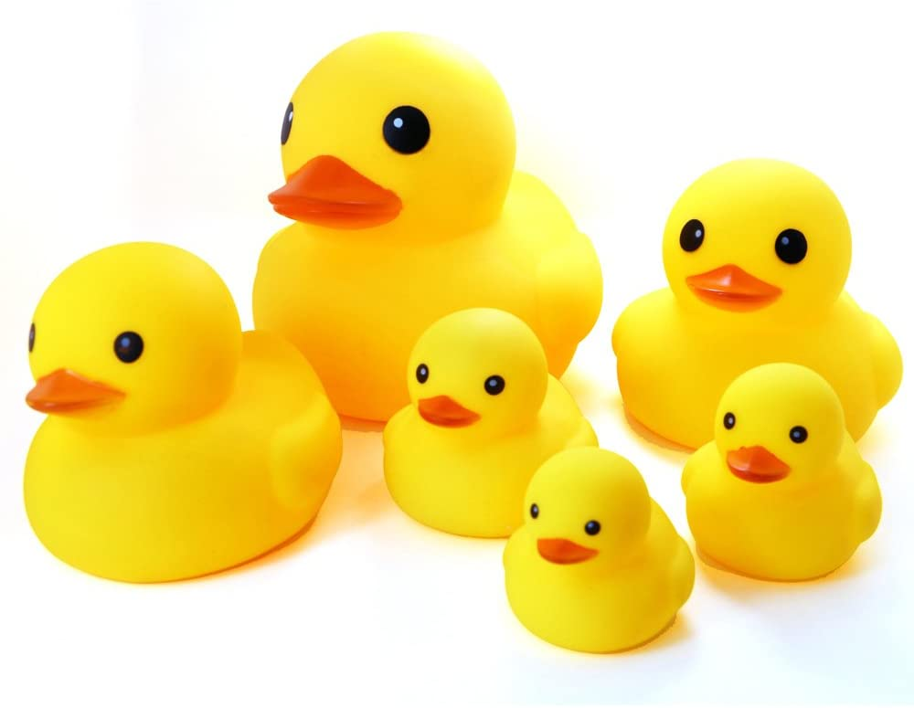If you have any of these rubber ducks at home there are lots of activities you could do with them:
- Have some fun with floating them in some water/fishing them out.
- Duck races- reinforcing the language 1st, 2nd and 3rd from activities last time
- Write some letters underneath the ducks from the sound mat-
fish the ducks out, saying the sound underneath the duck. You could also play duck sound bingo. On a blank piece of paper draw out a simple grid and put some of the letters you’ve written underneath the ducks in the grid. Take it in turns to fish out the ducks, check your bingo sheet and colour it in/cross it off if you have the letter.
s | g
o | i
n | a

Children can also practise writing the letters they’ve fished out.

- Write numbers on the ducks. Say a number and children have to try and fish out the correct number.
- Get them to fish out a duck- you say the incorrect number and they have to tell you whether you are wrong or right and then tell you what the correct number is.
Garden Bird Watch:
- Spend some time every day looking at what birds are in the garden, remind the children that they will need to be still and quiet or they’ll frighten the birds away. Perhaps they may spot the same birds coming back every day or one day there may be a surprise visitor. If possible take a picture of the birds spotted in the garden, you can then use the picture and the link below to find out the name of that bird and listen to the sound it makes.
https://www.rspb.org.uk/birds-and-wildlife/bird-songs/what-bird-is-that/
Bird Feeders:
You could make a bird feeder to attract more birds into your garden for you to watch. Here are just some ideas to help you.
Cheerio Bird Feeder:
You will need:
Cheerios/other cereal with a hole in the middle.
String/pipe cleaners.
Thread the cereal onto the string/pipe cleaners and hang out in the garden.
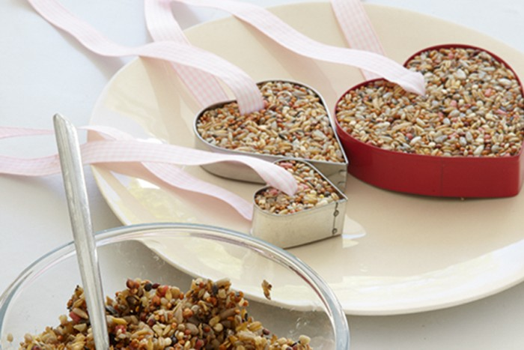
You Will Need:
- 100g lard
- 250g mixed bird seed
- Large biscuit cutter
- Ribbon

